**REPORT WRITING**

**Ecommerce customer data**

This project delves into the fascinating world of online shopping behavior, aiming to unlock valuable insights that can revolutionize the customer experience and drive business success. By analyzing a wealth of data, we embark on a journey to answer key questions:

**Research questions**

**1**.Can a user make purchases based on their browsing time?

2.Is there a significant difference in browsing time between genders, or is it negligible?

3.Which device type (e.g., mobile phones, tablets, Desktops) drives the most total purchases?

4.Do different age groups tend to reside in specific geographical regions or countries?

5.Do specific locations generate a significantly higher number of total purchases compared to others?

6.Do customers who add more items to their cart tend to make higher total purchases?

7.Are there significant differences in device usage across different age groups?

8.Do users who spend more time browsing products tend to view more pages?

9.Do users who view more pages tend to make more purchases overall?

**Discoveries and insights**

My analysis starts with graphs showing distribution of variables Age and Device type, this was done to check the ages of the customers in our website and the different types of devices available for sale.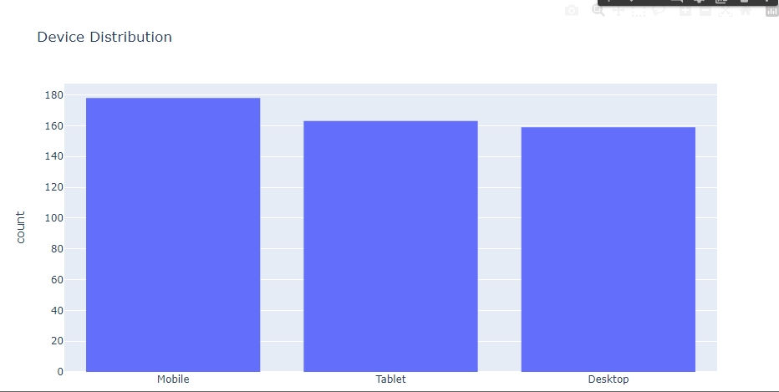

The above graph shows device type distribution

There are many mobile phones, followed by tablets and lastly desktops because smartphones are increasingly used for online shopping due to their constant accessibility and portability, allowing customers to browse and purchase anywhere, anytime. This calls for considering developing a native mobile app to offer an even more convenient and engaging shopping experience.

The following graph shows the relationship between total purchases and product browsing time

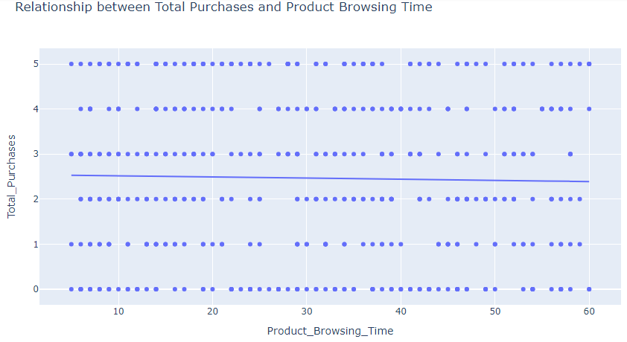

The straight line with a negative slope indicates an inverse relationship, where one variable increases as the other decreases, this could be due to Impulse purchases whereby customers make quick decisions and purchase immediately might have lower browsing times.It calls for product pages designed to be engaging and informative, prompting users to spend more time and visit more related pages.

The graph below shows the relationship between product browsing time per gender

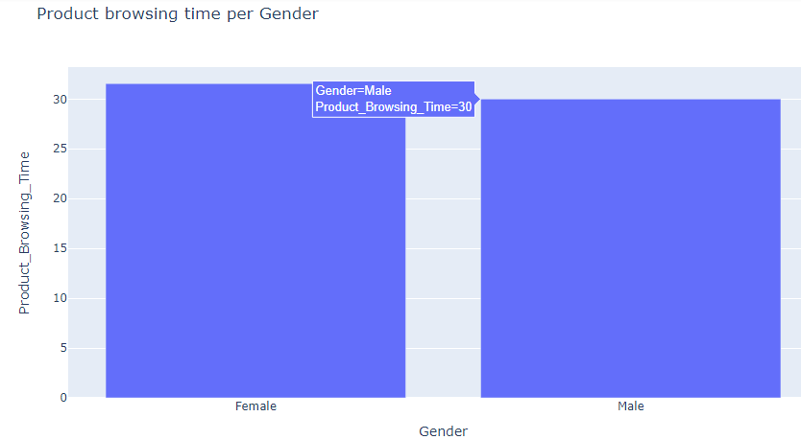

Females have a product browsing time of 31mins and more while males have a product browsing time of 30mins , which means females have high product browsing time than males.We should create an engaging and informative browsing experience for all users, regardless of gender. Focus on understanding individual needs and preferences.

The pie chart below shows percentage purchase by device type

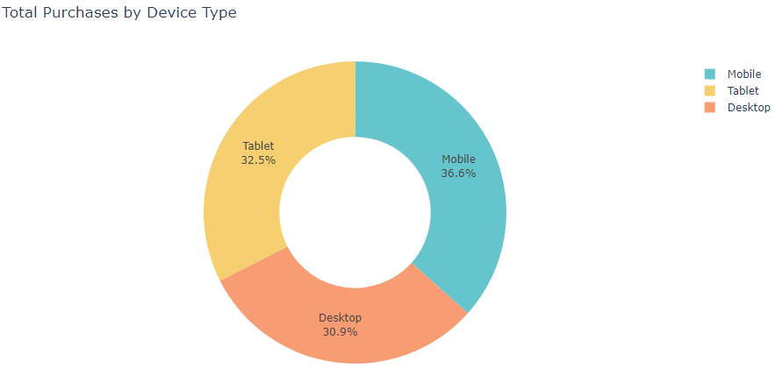

The desktops have a low purchase of 30.9% ,followed by the tablets with 32.5% and lastly the mobile phones which have a high purchase of 36.6%, Its because Mobile phones are portable and allow for online purchasing and research anywhere, anytime and fitting seamlessly into busy lifestyles , It calls for providing high-quality product images, detailed descriptions, and specifications that are easily accessible on desktops and tablets.

The graph below shows the location by age relationship

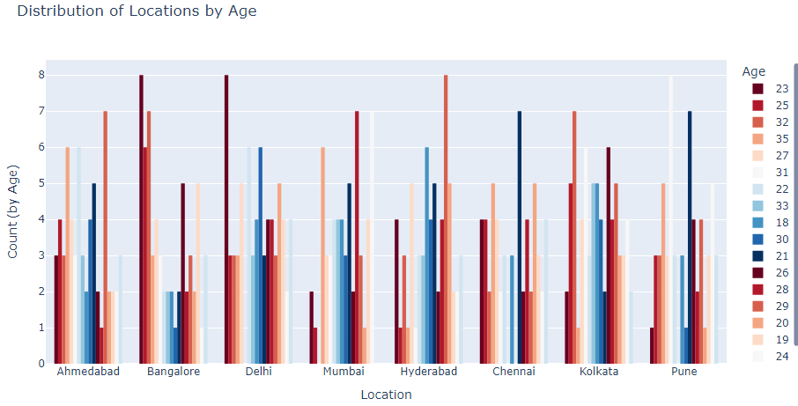

There are many people aged 23 years from Bangalore and Dehli, there are also many people aged 29 years old in Hyderabad the rest show cyclic relationship with increasing and decreasing pattern, this could be because of the cost of living, job opportunities, and career prospects can influence where people choose to live and work, leading to age-specific concentrations. This can be addressed by digital marketing channels, and global payment solutions to reach customers worldwide.

The graph below show total purchases by items added to cart

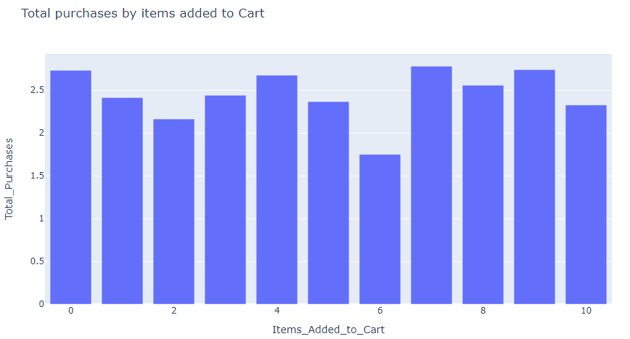

There is a large number of items added to cart with only a small portion being purchased, It indicates a gap between browsing and buying.It suggests there might be factors hindering users from completing their purchases. Users might add items to compare features, get an idea of total cost, or simply browse without a firm purchase intent. Surprising shipping charges, taxes, or other fees during checkout can cause sticker shock and abandonment. Provide various delivery options and clear return policies to reduce concerns and also offer discounts or incentives to users who are about to leave without purchasing.

The graph below shows device type by age

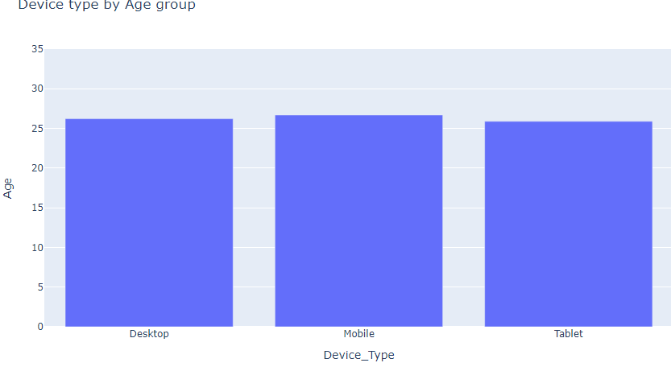

There is a slight difference in the device type by age across all the devices, desktop was purchased by mostly age 26 or more, mobile phone also and lastly tablets were purchased by 25 or more years of age. People around 25-26 years old often reach financial independence and are more likely to make discretionary purchases like electronics. I think it's because at this age, individuals might be starting careers, attending university, or transitioning to living on their own, leading to different device needs. The solution is to cater to different budgets and preferences by providing a range of options within each device category.

The graph below shows product browsing time by total pages viewed.

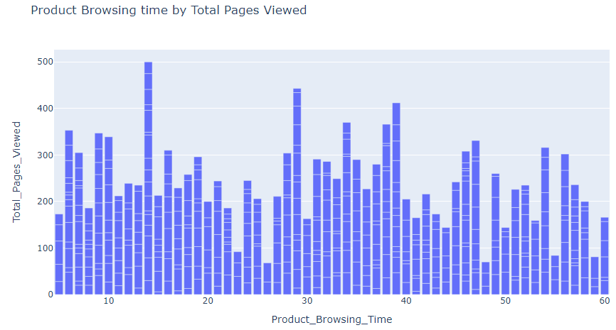

According to the above graph more product browsing time doesn't necessarily mean that many pages are being viewed because we see some high browsing times with few pages viewed and low browsing times with many pages viewed, i think it is because users might revisit specific pages or spend more time on certain product details, leading to higher browsing time without necessarily viewing more pages or pages with rich content and detailed information might require more time to absorb, even if they're fewer in number. The best solution is to define what constitutes "engaged browsing" for a specific website and goals. Is it viewing multiple pages, clicking on specific elements, or spending time on key content areas?

The graph below shows total purchases by total pages viewed

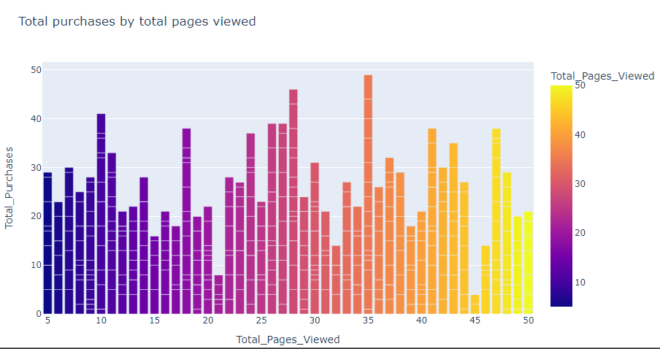

Total pages viewed has a slight impact on total purchases because we see many pages viewed with less purchases and less pages viewed with more purchases, This can indicate deeper engagement with specific products. The solution can be mapping user journeys through the website to see how they navigate and engage with different content, identifying potential drop-off points or areas for improvement.

The graph below shows correlation matrix on numerical variables

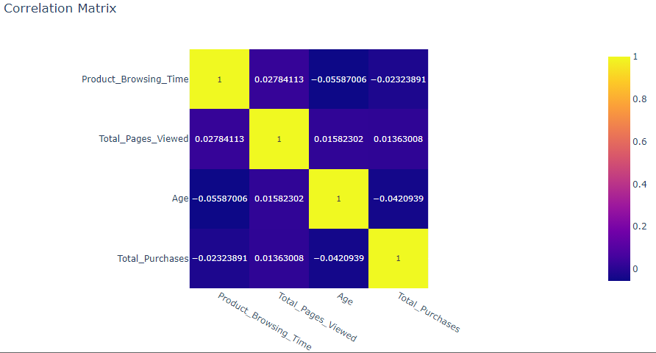

The graph above shows a strong negative relationship between variables and a weak or no relationship at all

**Conclusion**

This project is a deep dive into customer data, using advanced analytics to unlock hidden behavior patterns. Its goals are ambitious, aiming not just for surface-level understanding, but to uncover the "why" behind customer actions and decisions. By leveraging these insights, the project seeks to personalize the shopping experience, increase engagement, predict behavior, and ultimately boost conversion rates and business success. In essence, it's about harnessing the power of customer data to create a more compelling online journey that drives customer loyalty and growth.

## 